Adding ip address into list
Attempt | Input | Expected | Actual | P/F
1 | blank | Invalid ip | Invalid ip | P
2 | No dots | Invalid ip | Invalid ip | P
3 | One instead of 1 | Invalid ip | Invalid ip | P
4 | word | Invalid ip | Invalid ip | P
5 | 192.168.0.1 | Valid ip | Valid ip | P

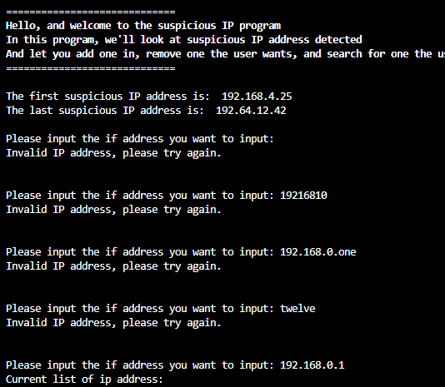

Ip address to remove
Attempt | Input | Expected | Real | P/F
1 | blank | IP not found | IP not found | P
2 | 192.168.0.42 | IP deleted | IP deleted | P

Screen shot for attempt 1:
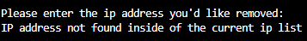

Screen shot for attempt 2:
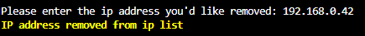

Look for IP

Attempt | Input | Expected | Actual | P/F
1 | blank | Invalid ip | Invalid ip | P
2 | 192.168.0.44 | Ip not found | Ip not found | P
3 | 192.168.0.0 | Ip found | Ip found | P

Attempt 1 screen shot:
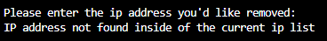

Attempt 2 screen shot:

Attempt 3 screen shot:

Crtl + C


